Cyngor Cymuned Llangynyw
Llangyniew Community Council
Clerc/Clerk; Georgia Marston Rhos Cynhinfa,
Pontrobert,
Meifod
SY22 6JP
Ffon/Phone; 07538 949878
Ebost/Email;llangynywclerc@gmail.com
10th September 2025
Dear Member,
You are summoned to attend a meeting of LLANGYNIEW COMMUNITY COUNCIL, to be held on Tuesday 16th September at Llangyniew Church at 19:30pm.

AGENDA
- Apologies
- Declaration of interest
- Minutes of Previous Meeting
- Information Arising from the minutes - to authorise the chairman to sign the minutes of the previous meeting of the council as a true and correct record.
- Chairmans Report
- County Councillors Report
- Correspondence
- Finance
  - Payments outgoing;
Clerks Wages & Expenses (Aug) –
Clerks Wages & Expenses (Sept) –
HMRC (Aug) -
HMRC (Sept) –
Bank Charges - £5.80
  - Payments Incoming;
Interest - £10.74
Precept - £3,923.00
  - Account Balances;
Current; £10,116.70
Deposit; £8,183.85
- Highways

- Planning
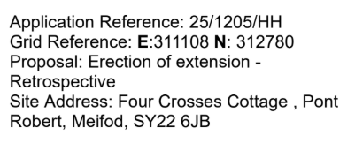
- Code of Conduct Training
- Section 6 Biodiversity Resilience – Projects and ideas.
- To confirm the Council Meeting to be held in; Llangyniew Church on Tuesday 21st October 2025 at 19:30pm.

Yr eiddoch yn gywir,
Yours sincerely,
G H Marston
Georgia Marston
Clerc i'r Cyngor Cymuned
Clerk to Community Council

